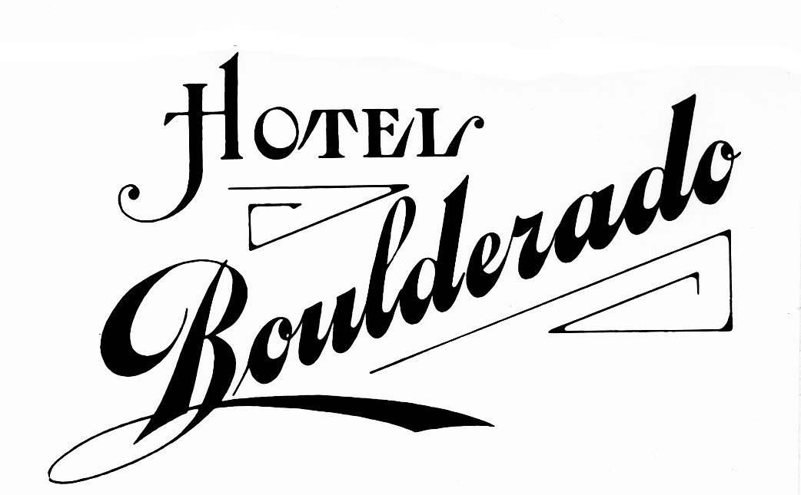

CU Physics Department ROOM RATE HOLD

Oct 25 – 28, 2012

The following discounted rates are being honored
based on hotel availability.
This discounted room rate is also available to your guests
for any additional nights adjacent to the above dates, based on availability.

To make reservations reference BID #11844
Phone 1.800.443.4344 / Email reservations@boulderado.com / Fax 303.443.7035

Traditional Queen: $169
1 Queen Bed
No Rollaways Available

Deluxe 2 Queens: $189
2 Queen Beds

Boulderado King: $209
1 King Bed

Classic King: $219
1 King Bed w/ Special Features

Elegant 1 Bedroom Suite: $259
1 King Bed or 2 Queen Beds
Living Room with Sofa Sleeper

Cancellations Must Be Made 4:00pm 3 days prior to arrival

Room Rates Do Not Include 12.3% Tax. Taxes subject to change without notice.

Rates based on double occupancy. $15 Per Additional Guest

Valet Parking: $10 per car – per night. Valet parking is not included in the room rate.
- Check-In Time ~ 4:00 P.M. Check-Out Time ~ 11:00 A.M.

FOR BOULDER INFORMATION GO TO
www.bouldercoloradousa.com
FOR HOTEL BOULDERADO INFORMATION GO TO
www.boulderado.com
(Group rates are not available through the web-site)

