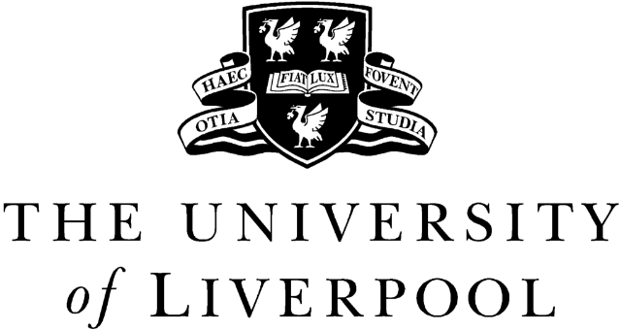

Department of Mathematical Sciences

MATH191
SYLLABUS 2014-2015

Mathematics 1 for Electrical Engineers

No of Lectures

9 FUNCTIONS and GRAPHS: Graphs of simple functions including examples of polynomial
and rational functions. Asymptotes and zeroes. Monotonicity, inverse functions. Even, odd and periodic functions. Trigonometric functions of angles of arbitrary magnitude, inverse trigonometric functions. Solution of trigonometric equations. Polar coordinates, simple polar plots. Limits and continuity. Examples involving sums, products and quotients - including lim (sin x)/x.

- DIFFERENTIATION: Differentiation as a limit using simple examples. Rules for other
common functions. Product, quotient and chain rules. Tangent to y=f(x). Location of roots of f(x)=0 by Newton's method. Differentiability and higher derivatives. Maclaurin and Taylor series expansions. L’Hôpital’s rule. Properties of exponential, logarithmic, and hyperbolic functions. Implicit differentiation. Stationary points and extrema. Curve sketching.

- INTEGRATION: Definite integral as the area under a curve. Basic properties. The Fundamental Theorem of Calculus (relation to differentiation). Indefinite integrals. Integrals of common functions.

3 VECTORS: Linear properties: addition, subtraction, scalar multiplication. Unit vectors. Displacement and position vectors. Angles, lengths and scalar product.

- COMPLEX NUMBERS: Historical motivation. Definition of complex numbers: real and
imaginary parts. Complex conjugate. The Argand diagram. Arithmetic with complex numbers. Polar form: modulus and argument, Euler’s formula and de Moivre’s theorem. Application of de Moivre’s theorem to trigonometric identities. Roots of complex numbers.

- SERIES: Convergence and divergence of series (heuristic treatment). Examples of
geometric and harmonic series. Comparison, ratio, and alternating series tests. Power series and radius of convergence.
__
36 lectures in total

Recommended course text: Glyn James: Modern Engineering Mathematics, 3rd edition, Prentice Hall (2001).

Prof A Faraggi

